**Elasticsearch Data Demands (Teacher)**

Created by: Scott Harris and Noah Dunn

**Dataset Description:**

The documents provided in the sample data take the form:

{

"first_name": "Cesar",

"last_name": "Yosselevitch",

"fav_animal": "Hornbill, southern ground",

"gender": "Male",

"fav_application": "Sonair"

}

All data was pseudo-randomly generated using the website [Mockaroo](https://www.mockaroo.com/)

**Database Insertion Information**

1. Download this  [JSON data file](https://drive.google.com/file/d/1TLXYufXR7eWRdonnHX9hL-o01_dq5DtB/view?usp=sharing).
2. Execute this command in the same folder as the data file. Swapping in the correct values for the text in black.

curl -u "[INSERT_USERNAME_HERE_FOR_SERVER]":"[INSERT_PASSWORD_HERE_FOR_SERVER]" -s -XPOST -H "Content-type: application/x-ndjson" [INSERT_SERVER_IP_HERE]/_bulk --data-binary "@MOCK_DATA_FILE.json"

1. This will generate 1000 documents inside the people index.
2. Validate the documents were successfully inserted using

{

"query": {

"match_all" : {}

},

"size": 1000

}

**Data Demand 1:**

Determine all Females in the Database whose favorite animal is some type of Turtle

(Hint: No regular expression needed) Using Bool, Must, and Match (3 results)

Solution:

POST [IP_ADDRESS]/people/_search

Query:

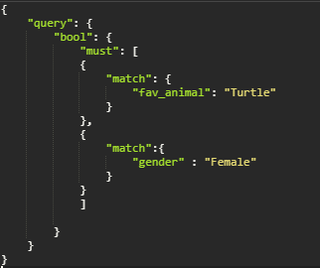

Result:

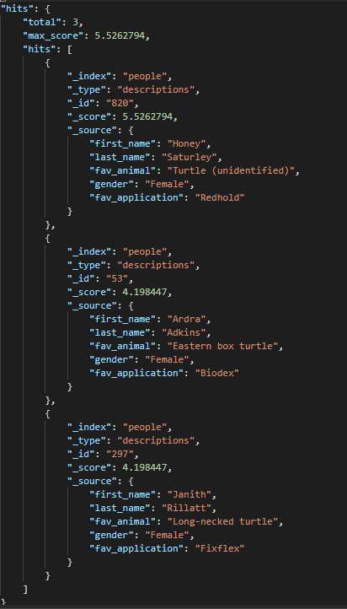

**Data Demand 2:**

Determine all people who either have a name similar to “alley” within a fuzziness of 2, or are male. Ensure the people found have at least a score of 2 to fit this criteria semi-decently. Make use of min_score, bool, should, match, and fuzziness. (15 hits)

Solution:

POST [IP_ADDRESS]/people/_search

Query:

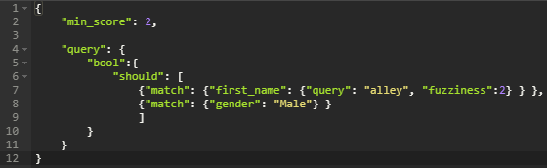

Response:

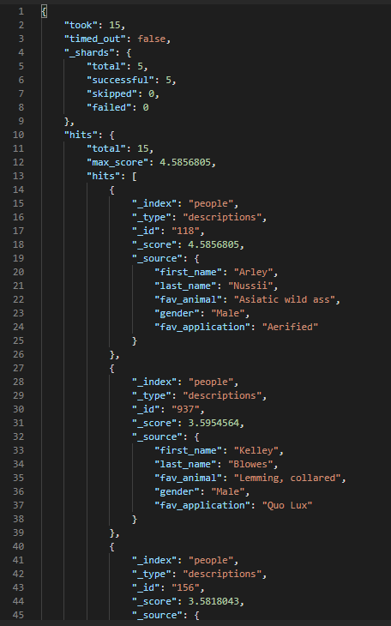

**Data Demand 3:**

Find the top 3 scored people whose first name, last name, or favorite animal is similar to “Kirk” with a fuzziness of 2 using multi_match with type ‘best score’ and a tie breaker of 0.3. Use multi_match, fuzziness, type, fields, tie_breaker, and size. (3 Results)

Query:

Solution:

POST [IP_ADDRESS]/people/_search

Query:

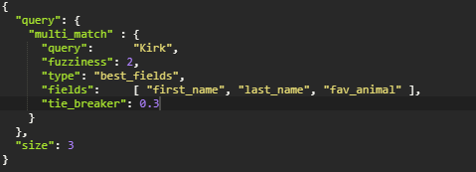

Response:

